***Homework 1***

Azamat Salamatov

MATH 1312 - STATISTICS

Professor Marvin E. Johnson

January 30, 2023

# Homework 1

Table of Contents

Homework 1 2

Section 43: 2

Section 51: 2

Section 57: 2

Section 63: 3

Section 81: 3

Section 87: 3

## Section 43:

***Q:*** For each of the following eight exercises, identify: a. the population, b. the sample, c. the parameter, d. the statistic, e. the variable, and f. the data. Give examples where appropriate.

43. Ski resorts are interested in the mean age that children take their first ski and snowboard lessons. They need this information to plan their ski classes optimally.

Answer: a) the population: all children who take their first ski and snowboard lessons;

b) the sample: the number of children chosen for survey (best option is to choose them randomly from random ski resorts at random time);

c) the parameter: the mean age of all children(the population) who take their first ski and snowboard lessons;

d) the statistic: the mean age of children in the survey(the sample) who take their first ski and snowboard lessons;

e) the variable: is the age of every child in a population

f) the data: the ages reported by the surveyed children in the sample, ex: 4, 6, 8, 9, 5, 13, etc.

## Section 51:

***Q:*** Use the following information to answer the next three exercises: A Lake Tahoe Community College instructor is interested in the mean number of days Lake Tahoe Community College math students are absent from class during a quarter.

51. Consider the following:

X = number of days a Lake Tahoe Community College math student is absent

In this case, X is an example of a:

a. variable.

~~b. population~~.

~~c. statistic.~~

~~d. data.~~

Answer: a) variable

## Section 57:

***Q:*** For the following exercises, identify the type of data that would be used to describe a response (quantitative discrete, quantitative continuous, or qualitative), and give an example of the data.57. number of students enrolled at Evergreen Valley College

Answer: Quantitative discrete ( the number of students can be counted)

Ex: 1353, 1989, 570, etc.

## Section 63:

***Q:*** Use the following information to answer the next two exercises: A study was done to determine the age, number of times per week, and the duration (amount of time) of resident use of a local park in San Jose. The first house in the neighborhood around the park was selected randomly and then every 8th house in the neighborhood around the park was interviewed.

63. “Number of times per week” is what type of data?

~~a. qualitative~~

b. quantitative discrete

~~c. quantitative continuous~~

Answer: b) quantitative discrete(number of times can be counted)

## Section 81:

***Q:*** 81. Sixty adults with gum disease were asked the number of times per week they used to floss before their diagnosis. The (incomplete) results are shown in Table 1.34.

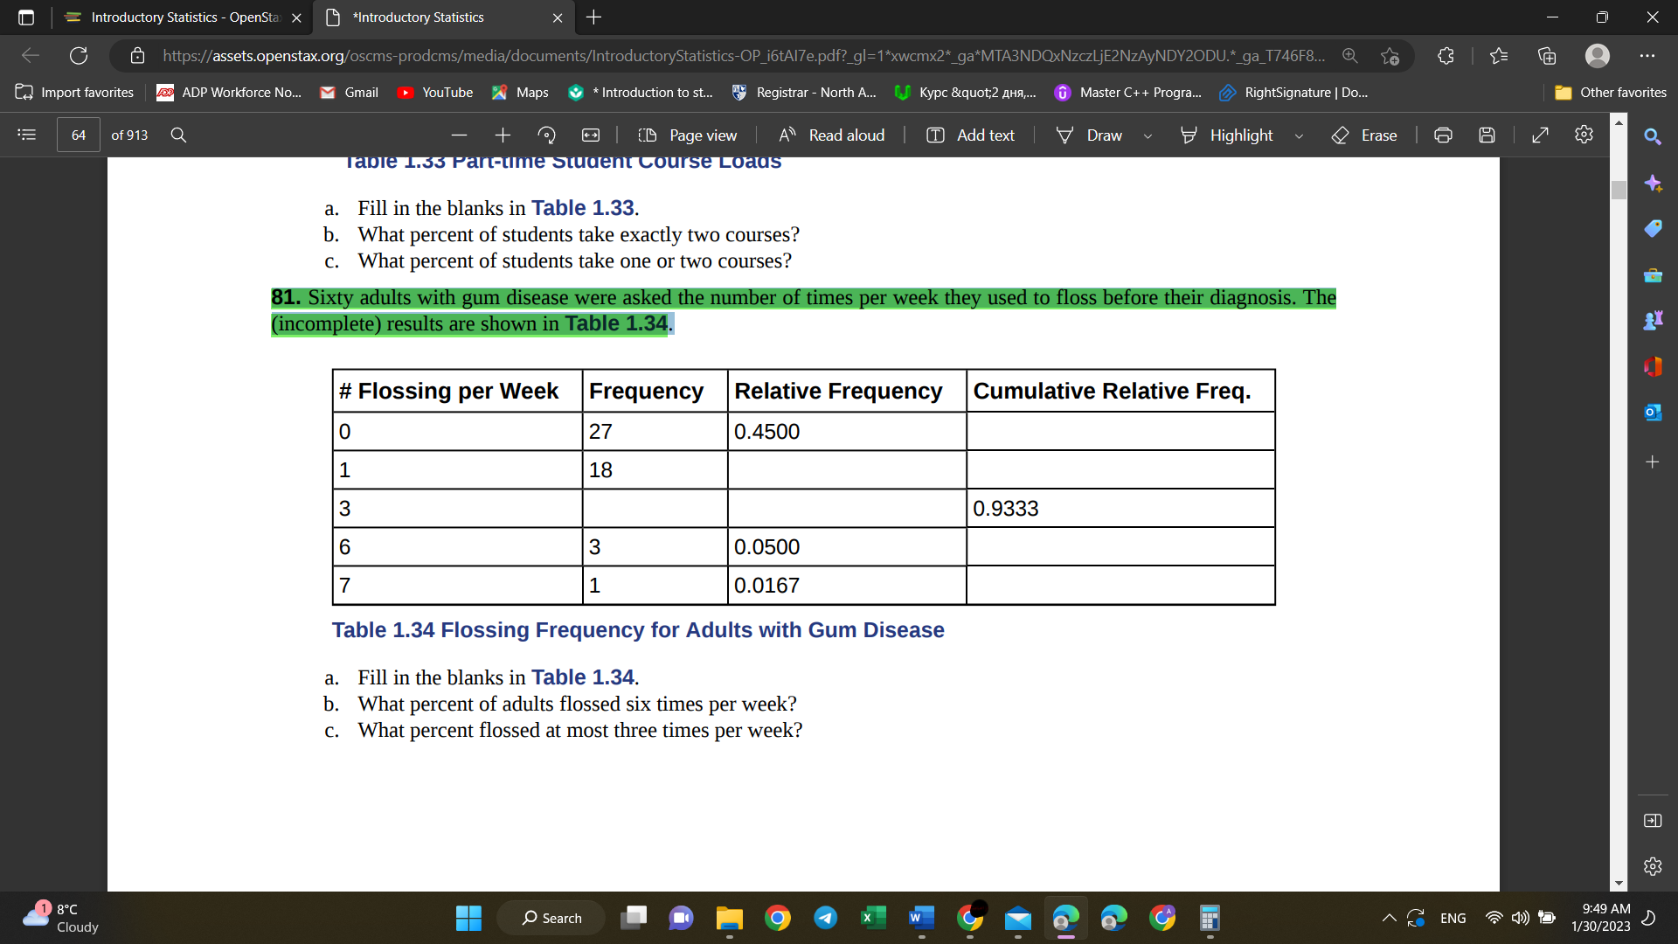

|  |  |  |  |
| --- | --- | --- | --- |
| # Flossing per Week | Frequency | Relative Frequency | Cumulative Relative Freq. |
| 0 | 27 | 0.4500 | 0.4500 =(relative freq.) |
| 1 | 18 | 0.3000 =(18/60) | 0.7500 =(0.4500+0.3000) |
| 3 | 11 =(60-27-18-3-1) | 0.1833 =(11/60) | 0.9333 |
| 6 | 3 | 0.0500 | 0.9833 =(0.9333+0.0500) |
| 7 | 1 | 0.0167 | 1.0000 =(0.9833+0.0167) |
|  | Total: 60 =(27/0.4500) | 1.0000 |  |

a. Fill in the blanks in Table 1.34.

b. What percent of adults flossed six times per week?

c. What percent flossed at most three times per week?

Answers: (red in the table)

b. What percent of adults flossed six times per week? =0.0500*100%= ***5%***

c. What percent flossed at most three times per week? =0.9333*100% = ***93.33%***

## Section 87:

***Q:*** 87. How does sleep deprivation affect your ability to drive? A recent study measured the effects on 19 professional drivers. Each driver participated in two experimental sessions: one after normal sleep and one after 27 hours of total sleep deprivation. The treatments were assigned in random order. In each session, performance was measured on a variety of tasks including a driving simulation. Use key terms from this module to describe the design of this experiment.

Answer:

1. The population: all people who drive
2. The sample: is 19 professional drivers
3. The experimental units: are the individual drivers in the study
4. The explanatory variable: is sleep quality
5. The treatments: are driving after normal sleep and driving after 27 hours of sleep deprivation
6. The response variable: performance while driving
7. Random assignment is present in the study
8. Possible lurking variables: daytime, road quality, car temperature, visibility, car quality, softness of seat in the car (some soft seats may stimulate sleep), etc.
9. Possible blinding: the researchers may not be aware of the condition of the drivers (whether they are driving after normal sleep or after 27-hour sleep deprivation)

Some errors in this experiment:

1. The research could be biased: because only professional drivers are selected as a sample
2. Sleep deprivation of only 27 hours: could cause bias: the better option would be to study driving performance after 5, 10, 15, 20, 25, 27 (or similar) hours of sleep deprivation
3. It is also unknown, the randomness of the selection: whether it is simple random, systematic, cluster, stratified or convenience. But it is known, that only professional drivers are selected.